# Calendar

*Update your calendar with these upcoming trade shows. conferences, and other events.*

* **April 3-5, 2025** - PEARL 2025 Con­

ference & Exhibition, Sheraton Charlotte Hotel, Charlotte, N.C. *Professional Elec­ trical Apparatus Reconditioning League, https://pear/1.org/conference-details.*

* **April 6-8, 2025** - Electrical Gen­

erating Systems Association Spring Conference, Sheraton Le Meridien, Char­ lotte, N.C. *Electrical Generating Systems Association, https:j/spring.egsa.org.*

* **April 29-May 1** - Facility Fusion,

Renaissance Austin Hotel, Austin, Tex. *The International Facility Management Association, https:j/facilityfusion.ifma.org.*

## April 28-30, 2025, 2025 - NECA

Legislative Conference, Salamander Washington DC, Washington, D.C. *National Electrical Contractors Associa­ tion, [www.necanet.org/legconf](http://www.necanet.org/legconf)*

* **May 18-21, 2025** - Electrical Equip­

ment Representatives Association's Annual Meeting, Ojai Valley Inn & Spa, Ojai, Calif. *Electrical Equipment Represen­ tatives Association, [http://bit.ly/3BzYtMP.](http://bit.ly/3BzYtMP)*

* May 19-22, 2025 - Cleanpower 2025 Conference & Exhibition, Phoenix Convention Center, Phoenix, Ariz. *Ameri-*

**Adiustable Motor Base**

**keeps improving!**

*can Clean Power Association, https:j/c/ean power.org/expo.*

* **May 20-22, 2025** - NAED 2025

National Meeting, JW Marriott Marco Island Beach Resort, Marco Island, Fla. *National Association of Electrical Distribu­ tors, [www.naed.org/national-meeting.](http://www.naed.org/national-meeting)*

* **May 21-23, 2025** - Europump's

Annual Meeting and General Assembly, Hilton Prague, Prague, Czech Republic. *Europump, [http://bit.ly/4dt8TM2.](http://bit.ly/4dt8TM2)*

* **June 3-5, 2025** - CWIEME Ber­

lin, Messe Berlin, Berlin, Germany. *Hyve Group Ltd., https:jjberlin.cwiemeevents. com/home.*

* **June 11-12, 2025** - Coiltech North

America 2025, Suburban Collection Showplace, Novi, Mich. *QUiCKFairs,* [www.](http://www/) coil*tech.us.*

* **June 16-20, 2025** - Turbo Expo:

Turbomachinery Technical Conference & Exposition, Renasant Convention Cen­ ter, Memphis, Tenn. *American Society of Mechanical Engineers, hrtps:j/event.asme. org/Turbo-Expo.*

* **June 21-25, 2025** - ASHRAE

2025 Annual Conference, Sheraton Phoenix Downtown and Phoenix Con­ vention Center, Phoenix, Ariz. *American Society of Heating, Refrigerating and* Air­ *Conditioning Engineers, [www.ashrae.org/](http://www.ashrae.org/)* co *nf* erences/202*s-annuaI-conference­ phoenix.*

* **June 25-26, 2025** - AEE East Energy

Conference & Expo, Huntington Conven­ tion Center, Cleveland, Ohio. *Association of Energy Engineers, https:j/aeeeast.org.*

* **July 19-22, 2025** - EASA Conven­

tion 2025, Gaylord Opryland Resort and Convention Center, Nashville, Tenn. *Electrical Apparatus Service Association, https://easa.com/convention.*

* **July 22-24, 2025** - Safety25 Confer­ ence & Expo, Orange County Convention Center, Orlando, Fla. *American Society of Safety Professionals, https://safety.assp.org.*
* **August 6-8, 2025** - NSPECon, Inter­

Continental Kansas City at The Plaza, Kansas City, Mod. *National Society of Pro­ fessional Engineers, [www.nspecon.org.](http://www.nspecon.org/)*

* **September 8-11, 2025** - Fabtech

2025, McCormick Place. Chicago. *Fabtech Event Partners, [www.fabtechexpo.com.](http://www.fabtechexpo.com/)*

* **September 12-15, 2025** - NECA 2025 Convention and Trade Show, McCormick Place, Chicago, Ill. *National Electrical Contractors Association, http:// bit.ly/4f9BW0N.*

## September 17-19, 2025 - AEE

World Energy Conference & Expo, Geor­ gia World Congress Center, Atlanta, Ga. *Association of Energy Engineers, https:// aeeworld.org/conference.*

## September 29-October 2, 2025

* Canadian Manufacturing Technology Show, Toronto Congress Centre, Toronto. Ontario, Canada. *Society of Manufacturing Engineers, [www.cmts.ca.](http://www.cmts.ca/)*
  + **October 13, 2025** - Hydraulic

Institute Fall Conference, Kansas City Marriott Country Club Plaza, Kansas City, Mo. *Hydraulic Institute, [www.pumps.org/](http://www.pumps.org/) eventj2025-fa/l-conference.*

* + **February 2-4, 2026** - AHR Expo

2026, Las Vegas Convention Center, Las Vegas, Nev. *The Air-Conditioning, Heating, and Refrigeration Institute, www.ahrexpo. com/sa/es-floor-plan-2026.*

* + **June 13-16, 2026** - EASA Solu­

tions Expo, Rosen Shingle Creek, Orlando, Fla. *Electrical Apparatus Ser­ vice Association, https://easa.com/conven tion/future-easa-conventions.* - *Edited by Kevin Jones* **EA**

Our **Adjustable Motor Base is** continuously improving to be the most durable and long­ lasting motor base on the market. With the latest patent pending advancement,

Overly Hautz motor bases now last 5 to 9.5 times longer than thecompetition.

Decrease downtime and save money with extended motor base life cycles.

Read the verified factory test report at:

***[www.overlyhautz.com](http://www.overlyhautz.com/)***



**OVERLY HAUT% COMPANY**

"CONTINUALLYIMPROVING THEBESTMOTOR BASE"

**28** *ELECTRICAL APPARATUS* I APRIL 2025

*The Renaissance Austin Hotel in Austin, Tex., will be the setting April 29 through May 1 of the International Facility Management Association's Facility Fusion conference.* .

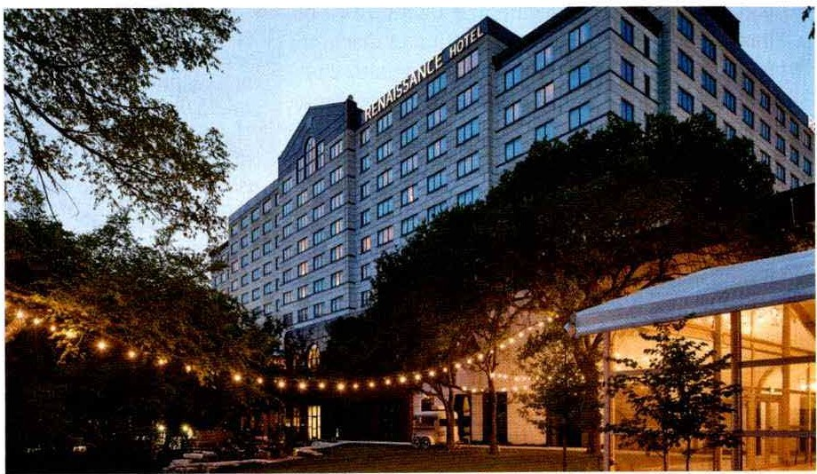- Marriott lnternattonal.Inc., photo

